

※ The information in this document is subject to change without notice and should not be construed as a commitment by Telechips, Inc.

Kindly visit [www.telechips.com](http://www.telechips.com) for more information.

**ⓒ 2025 Telechips Inc. All rights reserved.**

**Rev. 0.10 [G]**

**2025-03-19**

**Preliminary version**

**TCC805x** **Hardware**

**Application Note**

**For Telechips PMIC Design**

TABLE OF CONTENTS

**Contents**

TABLE OF CONTENTS 2

1 Introduction 3

2 Design Guide for TCC805x EVB 4

2.1 Telechips Components Information 4

2.1.1 Brief Specification of TCC5340 4

2.2 Block Diagram of PMICs Power Circuit 8

2.3 Design Guide for Preventing IR Drop 9

2.3.1 TCC5340 9

2.4 Power on and off Sequence 10

2.4.1 Transistor Circuit for Power on and off Control 10

2.4.2 Power on Sequence of PMIC and External LDO 11

2.4.3 Power off Sequence of PMIC, External Buck, and External LDO 12

2.5 Power Rail 13

3 Power-on and off Sequence 15

3.1 Power-on/off Sequence Timing of PMIC 15

3.2 Power on Waveform(TBD) 16

3.3 Power off Waveform(TBD) 16

4 References 17

5 Revision History 18

Rev. 0.10: 2025-03-19 18

**Figures**

Figure 2.1 Block Diagram of TCC5340 6

Figure 2.2 Waveform of Peak Current Duty (Single Phase) 8

Figure 2.3 Block Diagram of PMICs Power Circuit 9

Figure 2.4 Power Configuration of TCC5340 10

Figure 2.5 Transistor and Power Regulator Circuit 11

Figure 2.6 Power on Sequence Flowchart of PMIC and External LDO 12

Figure 2.7 Power off Sequence Flowchart of PMIC and External LDO 13

Figure 3.1 Power-on/off Sequence Timing of PMIC 16

**Tables**

Table 2.1 MTP_SEL Description of TCC5340 10

Table 2.2 Truth Table for Transistor Circuit 11

Table 2.3 Power Rail of Telechips PMIC Power Circuit 14

# Introduction

This document describes the design guide for Telechips Power Management Integrated Circuits (PMIC) applied to TCC805x and summarizes the test results on the TCC805x Evaluation Board (EVB).

# Design Guide for TCC805x EVB

The TCC805x EVB is designed by using TCC5340.

## Telechips Components Information

### Brief Specification of TCC5340

The TCC5340 is a highly integrated, multi-configurable power converter designed to provide functional safety. This device features dual multi-configurable synchronous buck converters and two LDOs, making it ideal for powering safety-related SoCs and application-specific integrated circuit chips (ASICs).

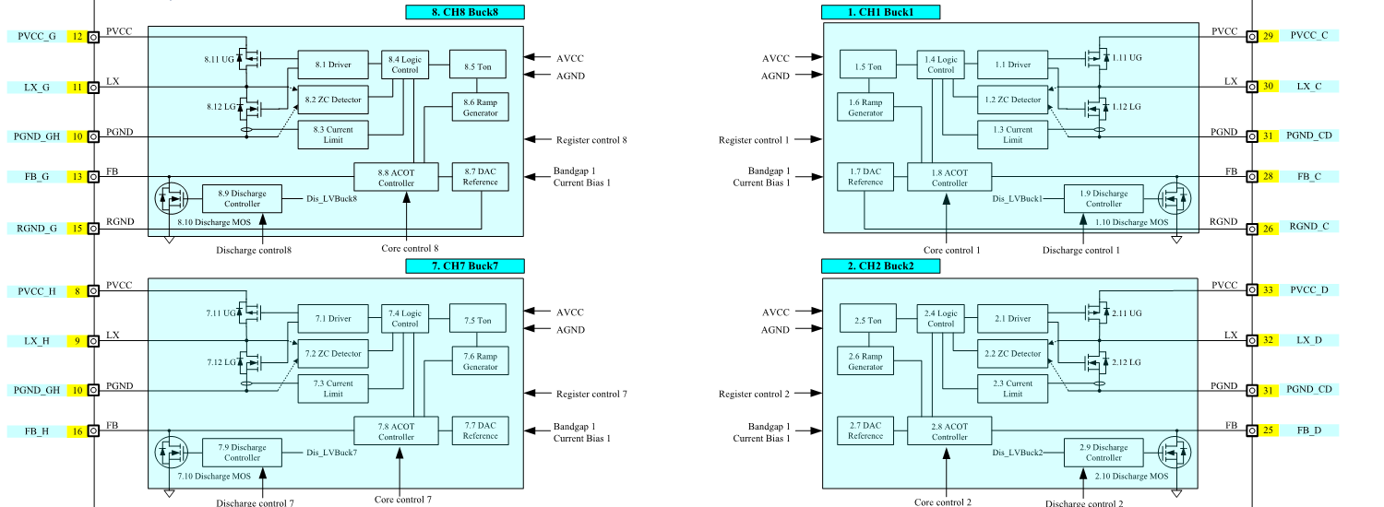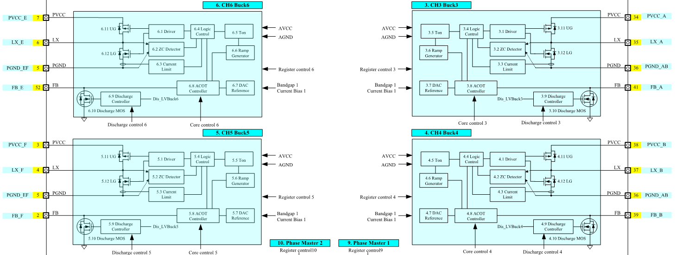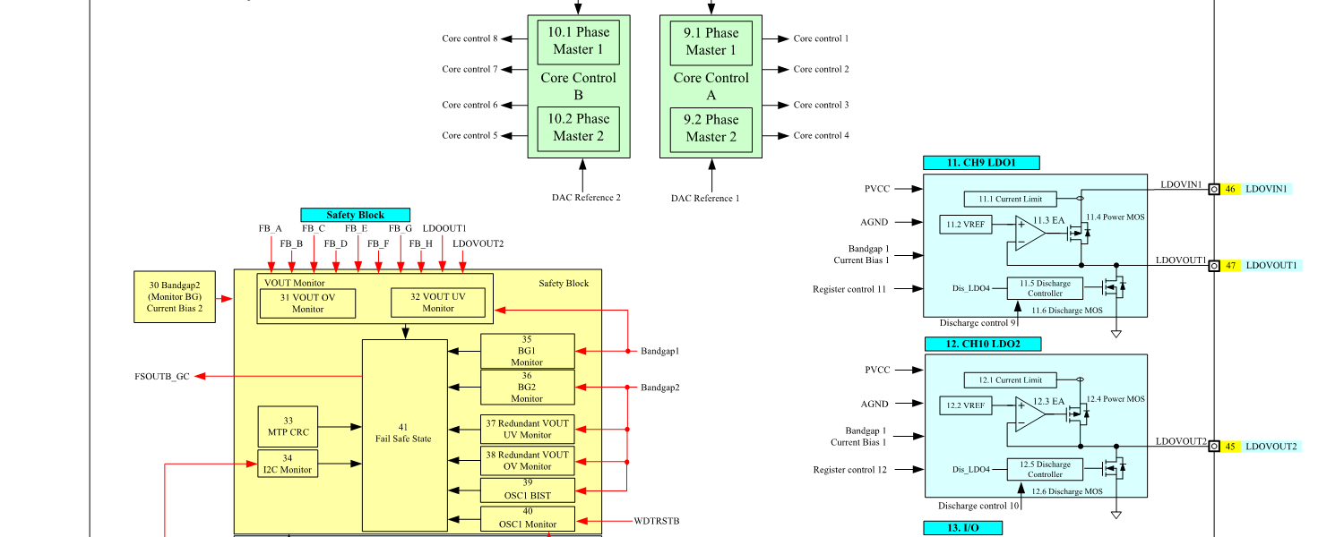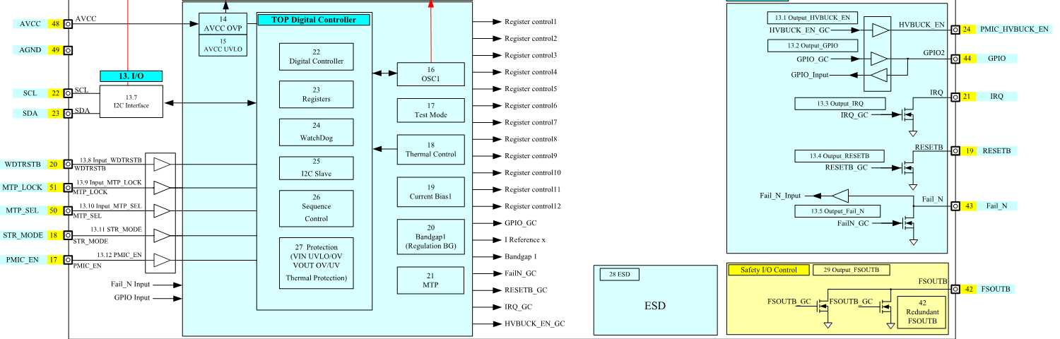

Figure . Block Diagram of TCC5340

#### Features

* Complies with ISO26262 ASIL-B
* AEC-Q100 Grade 1 qualified
* Integrated 8-channel buck converter and 2-channel LDO
* Dual multi-configurable buck converter with 4+0/3+1/2+2/2+1+1 configuration
* Input supply voltage: 3.6V to 5.5V
* 50 μA IQ in STR mode with BUCK_E and LDO1/2 Alive
* I2C programmable buck output voltage: 0.4V to 2.05V with typical switching frequency of 2 MHz
* Supports 3.3V and 1A output with typical switching frequency of 400 kHz on BUCK_A and BUCK_E
* Selectable LDO output voltage range
* LDO1: fixed to 1.2V, 1.8V, or 3.3V
* LDO2: fixed to 0.9V, 1.2V, 1.8V, or 3.3V
* LDO1 and LDO2 support 3.3V and 1.8V Dynamic Voltage scaling (DVS) through I2C
* Differential remote sense feedback for high accuracy
* Programmable soft-start and DVS slew rate
* Configurable rail sequence and default boot-up voltage stored in non-volatile memory (NVM)
* Power good and fail-safe indicators, windowed watchdog and watchdog reset function to prevent system hang
* Input OVLO/UVLO, Output OVP/UVP, thermal shutdown protection, and cycle-by-cycle current limit

#### TCC5340: Duty Limitation of Single-Phase Peak Current for BUCK

The duty limitation of the peak output current depends on the continuous output current (Idc) and the duty of peak current.

The single phase of TCC5340 is recommended to supply up to 5A peak for 50 ms.

* Condition: Vin 4V

|  |  |  |  |  |  |  |  |  |
| --- | --- | --- | --- | --- | --- | --- | --- | --- |
| **base lout (A)** | **Ta (°C)** | **peak from base Iout (A)** | **Max peak Iout (A)** | **Period (ms)** | **peak (ms)** | **duty** | **lavg (A)** | **Tj (°C)** |
| 3.2 | 85 | 0 | 3.2 | 100 | 100 | 1 | 3.2 | 137 |
| 3.2 | 85 | 1.8 | 5 | 100 | 100 | 0.1 | 3.38 | 141 |
| 3.2 | 85 | 1.8 | 5 | 100 | 50 | 0.5 | 4.1 | 145 |

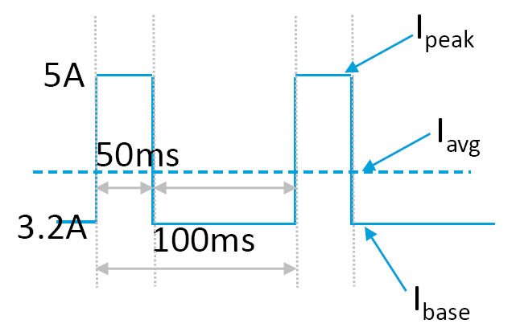

Figure . Waveform of Peak Current Duty (Single Phase)

## Block Diagram of PMICs Power Circuit

Figure 2.3shows the block diagram of PMICs power circuit

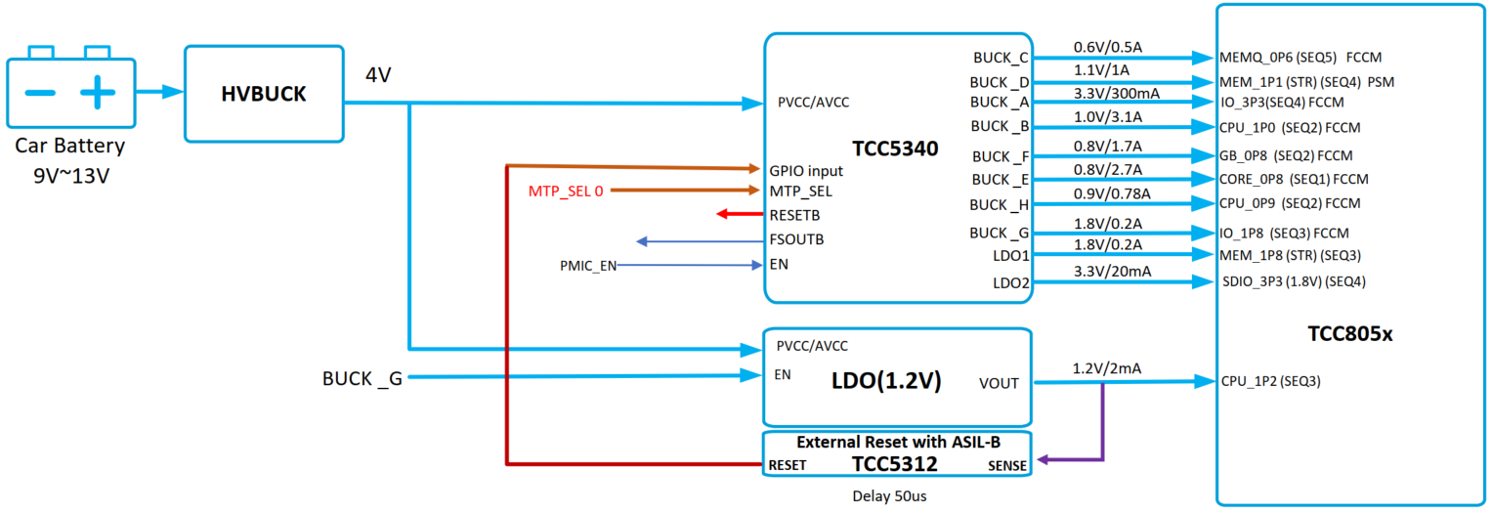

Figure . Block Diagram of PMICs Power Circuit

## Design Guide for Preventing IR Drop

IR drop refers to a voltage drop that appears at the resistive component of any impedance.

IR drop is the electrical potential difference between the two ends of a conducting phase during a current flow.

Depending on the environment of the PCB, an IR drop may occur.

If an IR drop occurs, you should increase and supply the voltage according to “*TCC805x Full Specification*”. [2]

Telechips PMICs have an I2C control function. If necessary, the voltage can be changed by using I2C.

### TCC5340

The TCC5340 is used in both LPDDR4 and LPDDR4X circuits. Figure 2.4 shows the power configuration of TCC5340.

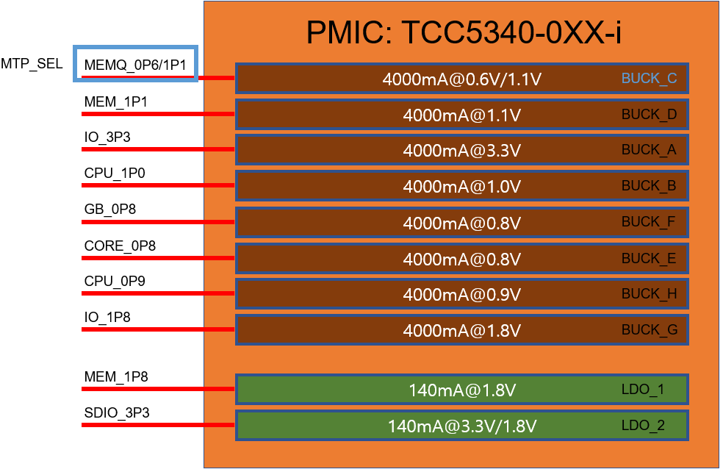

Figure . Power Configuration of TCC5340

Depending on the MTP_SEL selection, the voltage of the BUCK_C channel changes.

Table . MTP_SEL Description of TCC5340

|  |  |  |  |
| --- | --- | --- | --- |
| **Name** | **Status** | **Voltage** | **Application** |
| MTP_SEL | HIGH | 1.1V | LPDDR4 |
| MTP_SEL | LOW | 0.6V | LPDDR4X |

## Power on and off Sequence

### Transistor Circuit for Power on and off Control

**Power on sequence**

1. **PWR_CTLA** and **PWR_CTLB** are controlled by TCC805x when the power is turned on or waken up.
2. **PWR_EN** is logically high.
3. **HVBUCKEN** is logically high by **PWR_EN**: High with OR logic. (PWR_EN: High OR PMIC_HVBUCKEN: Low= High)
4. The high voltage buck is turned on.
5. PMIC is turned on and **PMIC_HVBUCKEN** is logically High.
6. The system is turned on.
7. **SYS_PWR_EN** is logically high and the peripheral device is turned on.

**Power off sequence**

1. **PWR_CTLA** and **PWR_CTLB** are controlled by TCC805x at the time of power off or power-down.
2. **PWR_EN** is logically low.
3. PMIC detects **PMIC_SYS_EN**: Low by **PWR_EN**.
4. PMIC processes power off sequence. At this time, the **PMIC_HVBUCKEN** pin is high, so the status of the high voltage buck can be kept as ON.
5. **SYS_PWR_EN** is logically low and the peripheral device is turned off.
6. **HVBUCKEN** is logically low by **PMIC_HVBUCKEN**: Low with OR logic. (PWR_EN: Low OR PMIC_HVBUCKEN: Low= Low)
7. The high voltage buck is turned off, and then the system goes into power off or power-down status.

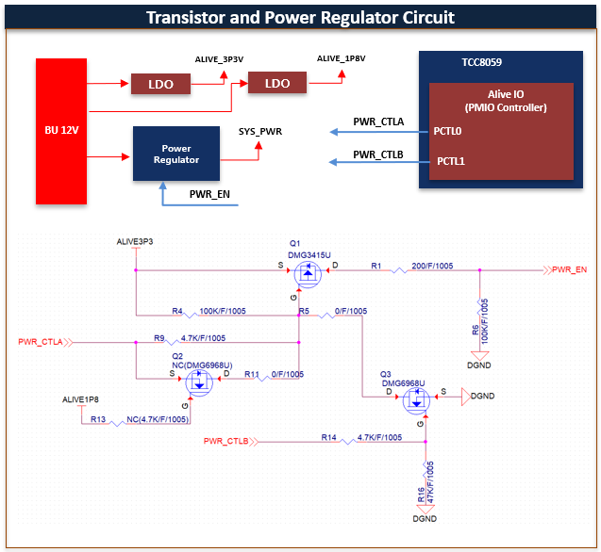

Figure . Transistor and Power Regulator Circuit

Table . Truth Table for Transistor Circuit

|  |  |  |  |
| --- | --- | --- | --- |
| PWR_CTLA | PWR_CTLB | PWR_EN | SYS_PWR |
| Low (0) | Low (0) | High (1) | ON |
| Low (0) | High (1) | High (1) | ON |
| High (1) | Low (0) | Low (0) | OFF |
| High (1) | High (1) | High (1) | ON |

### Power on Sequence of PMIC and External LDO

1. **PWR_EN** is logically high.
2. **HVBUCKEN** is logically high.
3. **TCC5340** is turned on.
   1. PMIC_BUCK_E On (CORE_0P8)
   2. PMIC_BUCK_B On (CPU_1P0)/ PMIC_BUCK_F On (GB_0P8)/ PMIC_BUCK_H On (CPU_0P9)
   3. PMIC_BUCK_G On (IO_1P8)/ PMIC_LDO1 On (MEM_1P8)/ EXT_LDO ON (CPU_1P2)
   4. PMIC_BUCK_A On (IO_3P3)/ PMIC_BUCK_D On (MEM_1P1)/ PMIC_LDO2 On (SDIO_3P3)
   5. PMIC_BUCK_C On (MEMQ_0P6 or *MEMQ_1P1)

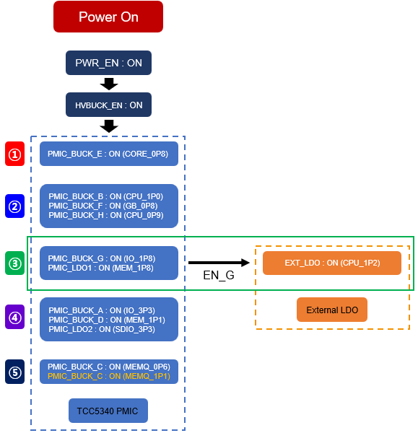

Figure . Power on Sequence Flowchart of PMIC and External LDO

### Power off Sequence of PMIC, External Buck, and External LDO

1. **PWR_EN** is logically low.
2. **HVBUCKEN** is logically high.
3. **PMIC_SYS_EN** is logically low.
   1. PMIC_BUCK_C Off (MEMQ_0P6 or *MEMQ_1P1)
   2. PMIC_BUCK_A Off (IO_3P3)/ PMIC_BUCK_D Off (MEM_1P1)/ PMIC_LDO2 Off (SDIO_3P3)
   3. PMIC_BUCK_G Off (IO_1P8)/ PMIC_LDO1 Off (MEM_1P8)/ EXT_LDO Off (CPU_1P2)
   4. PMIC_BUCK_B Off (CPU_1P0)/ PMIC_BUCK_F Off (GB_0P8)/ PMIC_BUCK_H Off (CPU_0P9
   5. PMIC_BUCK_E Off (CORE_0P8)
   6. HVBUCKEN is logically low.

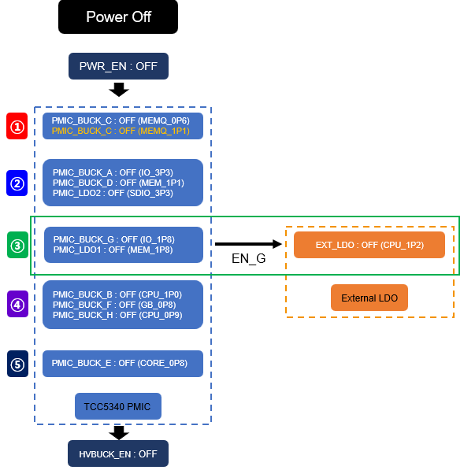

Figure . Power off Sequence Flowchart of PMIC and External LDO

\***Note:** In case use LPDDR4

## Power Rail

Table . Power Rail of Telechips PMIC Power Circuit

| PMIC Power Circuit | | | | | TCC8050/TCC8053 | | | |
| --- | --- | --- | --- | --- | --- | --- | --- | --- |
| Power on Sequence | Power off Sequence | Power  Supply | Output Voltage  [V] | Maximum Output Current  [mA] | Power Name | MIN  Voltage  [V] | TYP  Voltage  [V] | MAX  Voltage  [V] |
| 1 | 5 | PMIC_BUCK_E  (CORE_0P8) | 0.8 | 4000 | VDD08D_CORE | 0.76 | 0.8 | 0.84 |
| VDD08A_DPLL | 0.76 | 0.8 | 0.84 |
| VDD08A_PLL_GB | 0.76 | 0.8 | 0.84 |
| VDD08A_PLL_VB | 0.76 | 0.8 | 0.84 |
| VDD08A_NPLL | 0.76 | 0.8 | 0.84 |
| VDD08A_PLL_MICOM | 0.76 | 0.8 | 0.84 |
| VDD08A_PLL_CA72 | 0.76 | 0.8 | 0.84 |
| VDD08A_PLL_CA53 | 0.76 | 0.8 | 0.84 |
| VDD08A_PLL_MB | 0.76 | 0.8 | 0.84 |
| VDD08A_PLL_PCIE | 0.76 | 0.8 | 0.84 |
| VDD08A_PLL_MIPI | 0.76 | 0.8 | 0.84 |
| VDD08A_PLL_DPWRAP | 0.76 | 0.8 | 0.84 |
| VDD08A_PLL_SDM | 0.76 | 0.8 | 0.84 |
| VDD08A_PLL_SRVC | 0.76 | 0.8 | 0.84 |
| VDD08A_PLL_STRGB | 0.76 | 0.8 | 0.84 |
| LVDS0_P_VDD | 0.76 | 0.8 | 0.84 |
| LVDS1_P_VDD | 0.76 | 0.8 | 0.84 |
| LVDS2_P_VDD | 0.76 | 0.8 | 0.88 |
| USB30_VP | 0.76 | 0.8 | 0.84 |
| DP_PHY_VP08A | 0.76 | 0.8 | 0.84 |
| PCIE_VDD | 0.76 | 0.8 | 0.84 |
| VDD08D_DB | 0.76 | 0.8 | 0.84 |
| VDD08D_VB | 0.76 | 0.8 | 0.84 |
| 2 | 4 | PMIC_BUCK_F  (GB_0P8) | 0.8 | 4000 | VDD08D_GB | 0.76 | 0.8 | 0.84 |
| 2 | 4 | PMIC_BUCK_B  (CPU_1P0) | 1.0 | 4000 | VDD10D_CPUA72 | 0.95 | 1.0 | 1.05 |
| 2 | 4 | PMIC_BUCK_H  (CPU_0P9) | 0.9 | 4000 | VDD09D_CPUA53 | 0.855 | 0.9 | 0.945 |
| USB30_DVDD | 0.84 | 0.9 | 0.99 |
| UFS_VDD09A | 0.855 | 0.9 | 0.945 |
| UFS_VDD09A_CMN | 0.855 | 0.9 | 0.945 |
| VDD09D_USB20H | 0.84 | 0.9 | 0.99 |
| VDD09D_USB20DH | 0.84 | 0.9 | 0.99 |
| MS1_VDD_0P9 | 0.855 | 0.9 | 0.945 |
| MS0_VDD_0P9 | 0.855 | 0.9 | 0.945 |
| VDD09D_DMC | 0.855 | 0.9 | 0.945 |
| VDD09A_PLL_DDR0 | 0.855 | 0.9 | 0.945 |
| VDD09A_PLL_DDR1 | 0.855 | 0.9 | 0.945 |
| VDD09A_PLL_DDR2 | 0.855 | 0.9 | 0.945 |
| VDD09A_PLL_DDR3 | 0.855 | 0.9 | 0.945 |
| 3 | 3 | PMIC_BUCK_G  (IO_1P8) | 1.8 | 4000 | VDD18A_DPLL | 1.700 | 1.800 | 1.900 |
| VDD18A_PLL_GB | 1.700 | 1.800 | 1.900 |
| VDD18A_PLL_VB | 1.700 | 1.800 | 1.900 |
| VDD18A_PLL_MB | 1.700 | 1.800 | 1.900 |
| VDD18A_NPLL | 1.700 | 1.800 | 1.900 |
| VDD18A_PLL_MICOM | 1.700 | 1.800 | 1.900 |
| VDD18A_PLL_CA72 | 1.700 | 1.800 | 1.900 |
| VDD18A_PLL_CA53 | 1.700 | 1.800 | 1.900 |
| MS0_VDD18 | 1.710 | 1.800 | 1.890 |
| MS1_VDD18 | 1.710 | 1.800 | 1.890 |
| LVDS0_P_VDDIO18 | 1.710 | 1.800 | 1.890 |
| LVDS0_P_VDDPLL18 | 1.710 | 1.800 | 1.890 |
| LVDS1_P_VDDIO18 | 1.710 | 1.800 | 1.890 |
| LVDS1_P_VDDPLL18 | 1.710 | 1.800 | 1.890 |
| LVDS2_P_VDDIO18 | 1.710 | 1.800 | 1.890 |
| LVDS2_P_VDDPLL18 | 1.710 | 1.800 | 1.890 |
| USB30_VDD18 | 1.680 | 1.800 | 1.980 |
| USB30_VPH | 1.710 | 1.800 | 1.890 |
| VDD18A_USB20H | 1.680 | 1.800 | 1.980 |
| VDD18A_USB20DH | 1.680 | 1.800 | 1.980 |
| UFS_VDD18A_CMN | 1.710 | 1.800 | 1.890 |
| VDD18D_UFS_OSC | 1.710 | 1.800 | 1.890 |
| PCIE_VDDH | 1.710 | 1.800 | 1.890 |
| DP_PHY_VPH18A | 1.710 | 1.800 | 1.890 |
| VDD18D_DP_OSC | 1.710 | 1.800 | 1.890 |
| DP_AUX_VPH18A | 1.710 | 1.800 | 1.890 |
| VDD18P_IO | 1.650 | 1.800 | 1.950 |
| VDD18A_ADC | 1.700 | 1.800 | 1.900 |
| VDD18A_TS | 1.710 | 1.800 | 1.890 |
| VDD18P_GPSYS | 1.650 | 1.800 | 1.950 |
| UFS_VDD18A | 1.710 | 1.800 | 1.890 |
| VDD18D_MAIN_OSC | 1.710 | 1.800 | 1.890 |
| VDD18A_PLL_PCIE | 1.700 | 1.800 | 1.900 |
| VDD18A_PLL_MIPI | 1.700 | 1.800 | 1.900 |
| VDD18A_PLL_DDR0 | 1.700 | 1.800 | 1.900 |
| VDD18A_PLL_DDR1 | 1.700 | 1.800 | 1.900 |
| VDD18A_PLL_DDR2 | 1.700 | 1.800 | 1.900 |
| VDD18A_PLL_DDR3 | 1.700 | 1.800 | 1.900 |
| VDD18A_PLL_DPWRAP | 1.700 | 1.800 | 1.900 |
| VDD18A_PLL_SDM | 1.700 | 1.800 | 1.900 |
| VDD18A_PLL_SRVC | 1.700 | 1.800 | 1.900 |
| VDD18A_PLL_STRGB | 1.700 | 1.800 | 1.900 |
| VDD18D_GPSD0 | 1.650 | 1.800 | 1.950 |
| eMMC (VCCQ) | 1.650 | 1.800 | 3.600 |
| 3 | 3 | PMIC_LDO_1  (MEM_1P8) | 1.8 | 140 | DRAM_VDD1 | 1.700 | 1.800 | 1.950 |
| 3 | 3 | EXT_LDO  (MIPI_1P2) | 1.2 | 140 | M1_VDD12 | 1.14 | 1.2 | 1.26 |
| M0_VDD12 | 1.14 | 1.2 | 1.26 |
| VDD12D_UFS | 1.08 | 1.2 | 1.32 |
| 4 | 2 | PMIC_BUCK_A  (IO_3P3) | 3.3 | 4000 | USB30_VDD33 | 3.070 | 3.300 | 3.600 |
| VDD33A_USB20H | 3.070 | 3.300 | 3.600 |
| VDD33A_USB20DH | 3.070 | 3.300 | 3.600 |
| VDD33D_GPSD2 | 3.000 | 3.300 | 3.600 |
| VDD33D_GPA | 3.000 | 3.300 | 3.600 |
| VDD33D_GPB | 3.000 | 3.300 | 3.600 |
| VDD33D_GPC | 3.000 | 3.300 | 3.600 |
| VDD33D_GPE | 3.000 | 3.300 | 3.600 |
| VDD33D_GPG | 3.000 | 3.300 | 3.600 |
| VDD33D_GPH | 3.000 | 3.300 | 3.600 |
| VDD33D_GPMA | 3.000 | 3.300 | 3.600 |
| VDD33D_GPMB | 3.000 | 3.300 | 3.600 |
| VDD33D_GPMC | 3.000 | 3.300 | 3.600 |
| VDD33D_GPMD | 3.000 | 3.300 | 3.600 |
| VDD33D_GPSYS | 3.000 | 3.300 | 3.600 |
| SNOR (VCC) | 2.700 | 3.300 | 3.600 |
| eMMC (VCC) | 2.700 | 3.300 | 3.600 |
| 4 | 2 | PMIC_LDO_2  (SDIO_3P3) | 3.3 | 140 | VDD33D_GPSD1 | 3.000 | 3.300 | 3.600 |
| 4 | 2 | PMIC_BUCK_D  (MEM_1P1) | 1.1 | 4000 | DRAM0_VDDQ_CKE | 1.060 | 1.100 | 1.170 |
| DRAM1_VDDQ_CKE | 1.060 | 1.100 | 1.170 |
| LPDDR4_VDD2 | 1.060 | 1.100 | 1.170 |
| 5 | 1 | PMIC_BUCK_C  (MEMQ_0P6) | 0.6 | 4000 | LPDDR4_VDDQ | 0.570 | 0.6 | 0.630 |
| 5 | 1 | *PMIC_BUCK_C  (MEMQ_1P1) | 1.1 | 4000 | LPDDR4_VDDQ | 1.060 | 1.100 | 1.170 |

\***Note:** In case use LPDDR4.

# Power-on and off Sequence

## Power-on/off Sequence Timing of PMIC

Figure 3.1 shows the power-on sequence timing of PMIC.

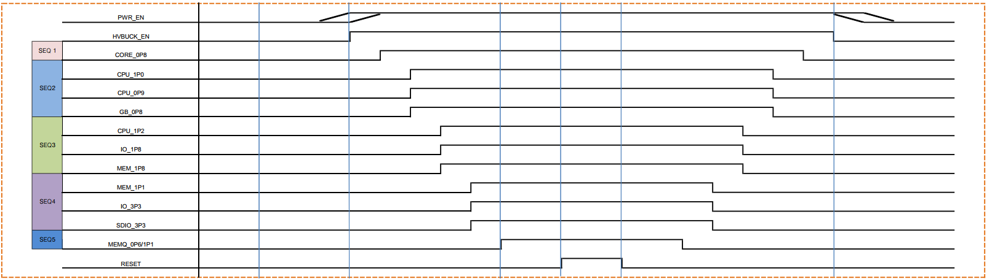

Figure . Power-on/off Sequence Timing of PMIC

The power sequence is determined by the internal OTP settings of PMICs. For detailed OTP information on PMIC, contact Telechips. [1]

## Power on Waveform(TBD)

## Power off Waveform(TBD)

# References

1. Contact Telechips for more details: [sales@telechips.com](mailto:auto_sales@telechips.com)
2. TCC805x Full Specification

**Note**: Reference documents can be provided whenever available, depending on the terms of a contract. If the reference

documents are unavailable, the contents directly related to your development can be guided.

# Revision History

## Rev. 0.10: 2025-03-19

* Preliminary version release

DISCLAIMER

This material is being made available solely for your internal use with its products and service offerings of Telechips, Inc (“Telechips”). and/or licensors and shall not be used for any other purposes. This material may not be altered, edited, or modified in any way without Telechips’ prior written approval. Unauthorized use or disclosure of this material or the information contained herein is strictly prohibited, and you agree to indemnify Telechips and licensors for any damages or losses suffered by Telechips and/or licensors for any unauthorized uses or disclosures of this material, in whole or part. Further, Telechips, Inc. reserves the right to revise this material and to make changes to its content, at any time, without obligation to notify any person or entity of such revisions or changes.

THIS MATERIAL IS BEING PROVIDED “AS IS” WITHOUT WARRANTY OF ANY KIND, WHETHER EXPRESSED, IMPLIED, STATUTORY OR OTHERWISE. TO THE MAXIMUM EXTENT PERMITTED BY LAW, TELECHIPS AND/OR LICENSORS SPECIFICALLY DISCLAIM ALL WARRANTIES OF TITLE, MERCHANTABILITY, NON-INFRINGEMENT, FITNESS FOR A PARTICULAR PURPOSE, SATISFACTORY QUALITY, COMPLETENESS OR ACCURACY, AND ALL WARRANTIES ARISING OUT OF TRADE USAGE OR OUT OF A COURSE OF DEALING OR COURSE OF PERFORMANCE. MOREOVER, NEITHER TELECHIPS, INC. NOR LICENSORS, SHALL BE LIABLE TO YOU OR ANY THIRD PARTY FOR ANY EXPENSES, LOSSES, USE, OR ACTIONS HOWSOEVER INCURRED OR UNDERTAKEN BY YOU IN RELIANCE ON THIS MATERIAL.

THIS MATERIAL IS DESIGNED FOR GENERAL PURPOSE, AND ACCORDINGLY YOU ARE RESPONSIBLE FOR ALL OR ANY OF INTELLECTUAL PROPERTY LICENSES REQUIRED FOR ACTUAL APPLICATION. TELECHIPS, INC. DOES NOT PROVIDE ANY INDEMNIFICATION FOR ANY INTELLECTUAL PROPERTIES OWNED BY THIRD PARTY.

Copyright Statement

Copyright in this material provided by Telechips, Inc. is owned by Telechips unless otherwise noted. For reproduction or use of Telechips’ copyright material, prior written consent should be obtained from Telechips. That prior written consent, if given, will be subject to conditions that Telechips’ name should be included and interest in the material should be acknowledged when the material is reproduced or quoted, either in whole or in part. You must not copy, adapt, publish, distribute, or commercialize any contents contained in the material in any manner without the written permission of Telechips. Trademarks used in Telechips’ copyright material are the property of Telechips.

**For customers who use Google technology:**

 "Copyright © 2013 Google Inc. All rights reserved.”